SVD GOVERNMENT DEGREE COLLEGE(W)
NIDADAVOLE, EAST GODAVARI DISTRICT-534301
(AFFILIATED TO ADIKAVI NANNYA UNIVERSITY, RAJAMAHENDRAVARAM)
E-Mail: nidadavolew.jkc@gmail.com
DEPARTMENT OF ENGLISH
EXTENSION ACTIVITIES
The Department of English through extension and outreach programs, we sensitize the students to develop social values, widespread their responsibilities and knowledge in societal issues and problems by making them to involve with the community people. Through this, we establish a good relationship and join hands with local community organization and serve the community. Students with profound interest attain the social values and responsibility.
The extension programme of the Department of English of SVD GOVT Degree College for the academic year 2023-24 was conducted on 23-01-2025. Faculty members of the department have conducted Vocabulary Enhancement classes to the students of Government Higher Secondary School, at Nidadavole.. Classes focused on English pronunciation, English Grammar and English vocabulary .The students exhibited great enthusiasm during the sessions. The programme offered a novel experience to the Faculty as well.
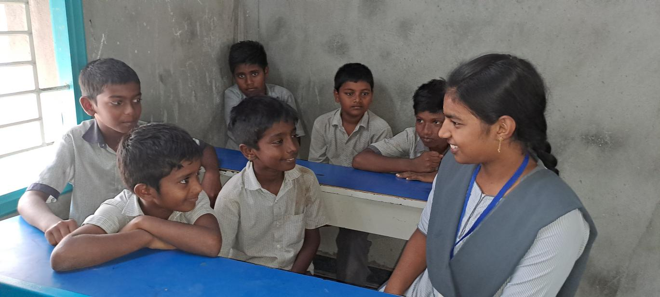
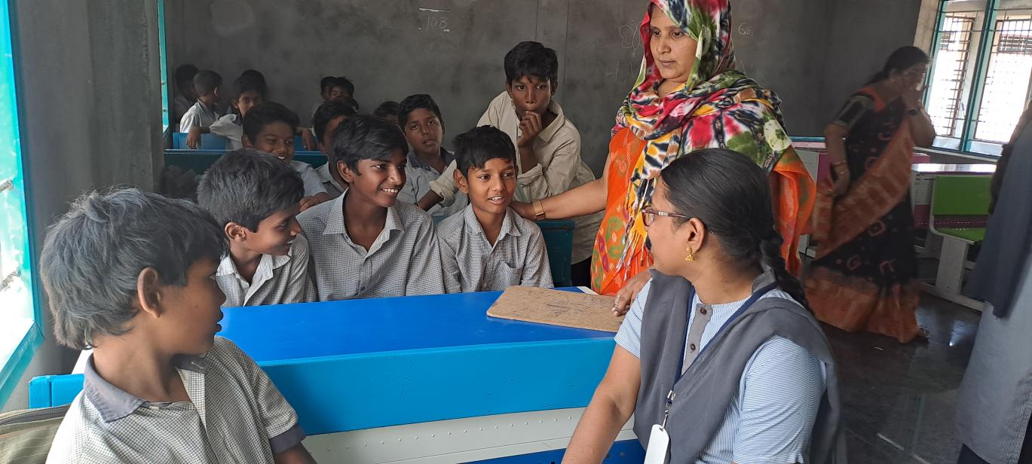
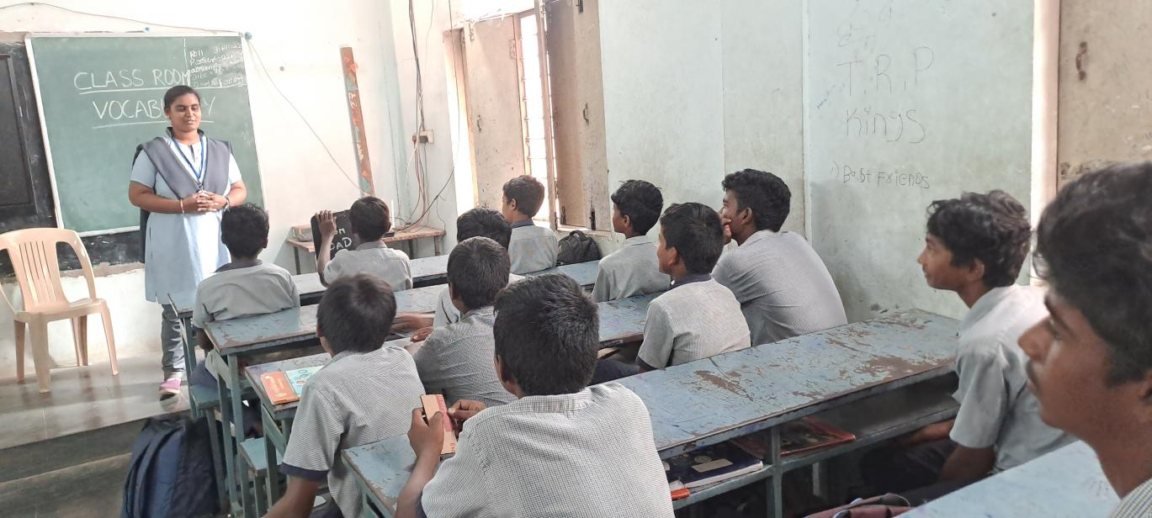
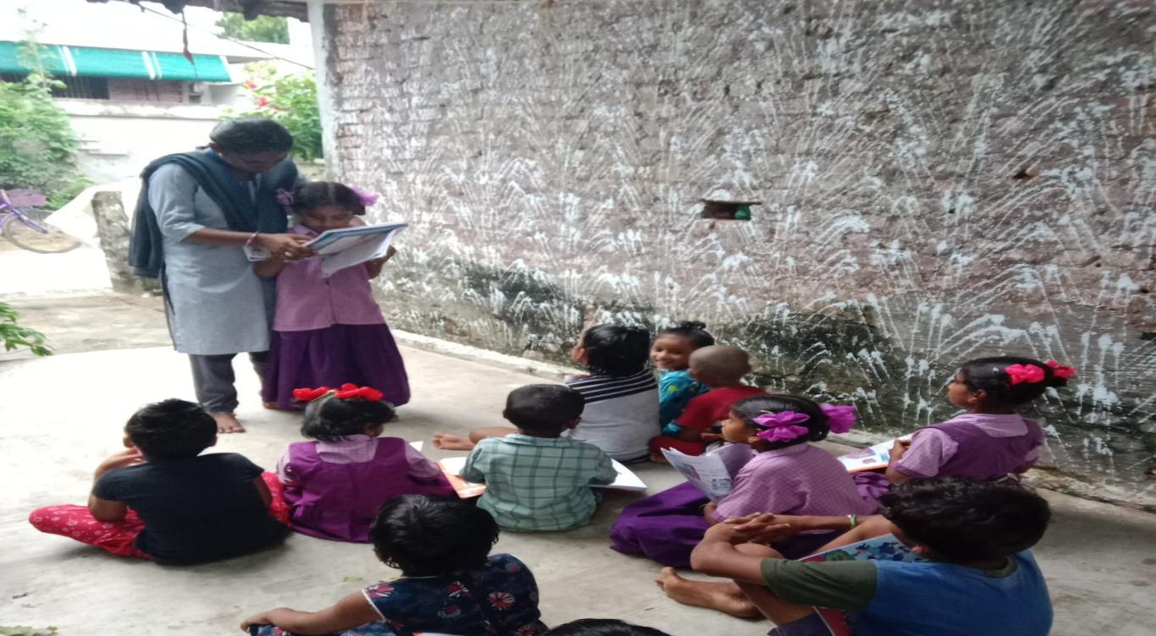
Students Involvement in Community Outreach Program
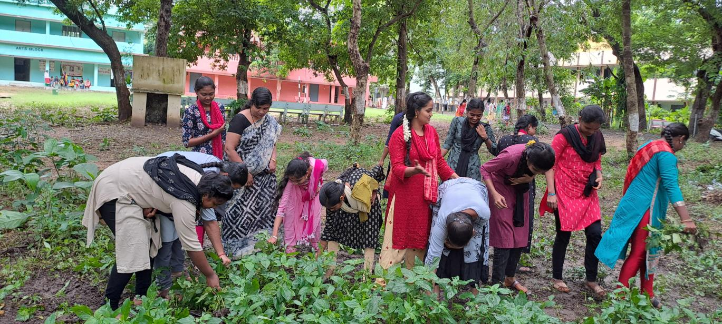
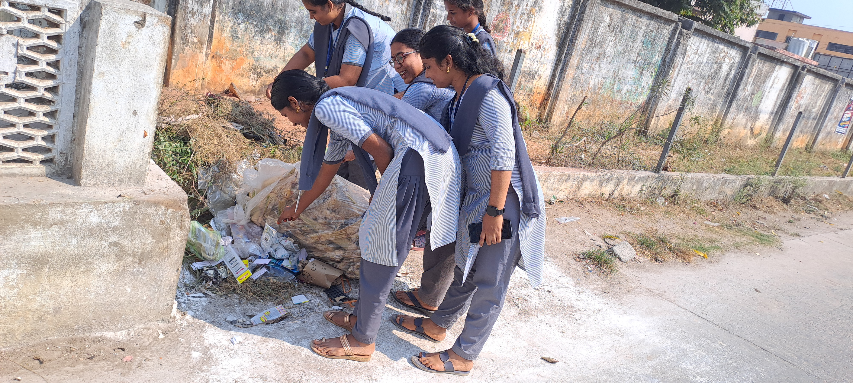
Students Involvement in Cleaning in and outside of the campus
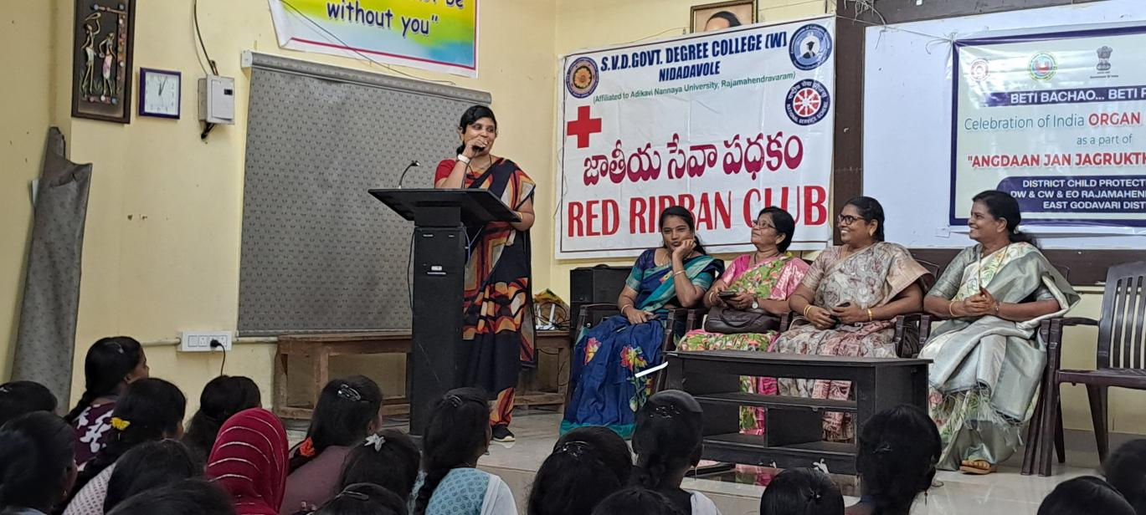
Organ Donation Awareness Program

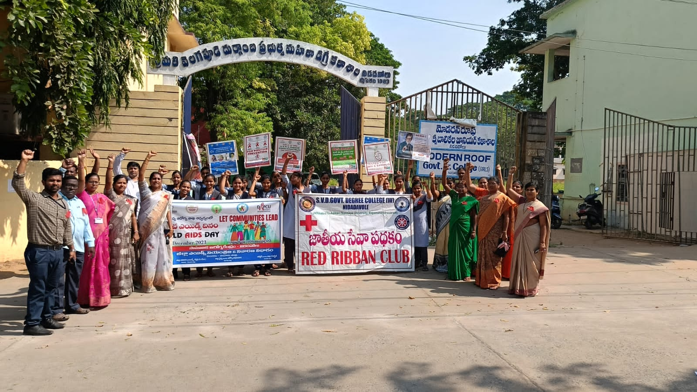
World Aids Day Awareness Rally

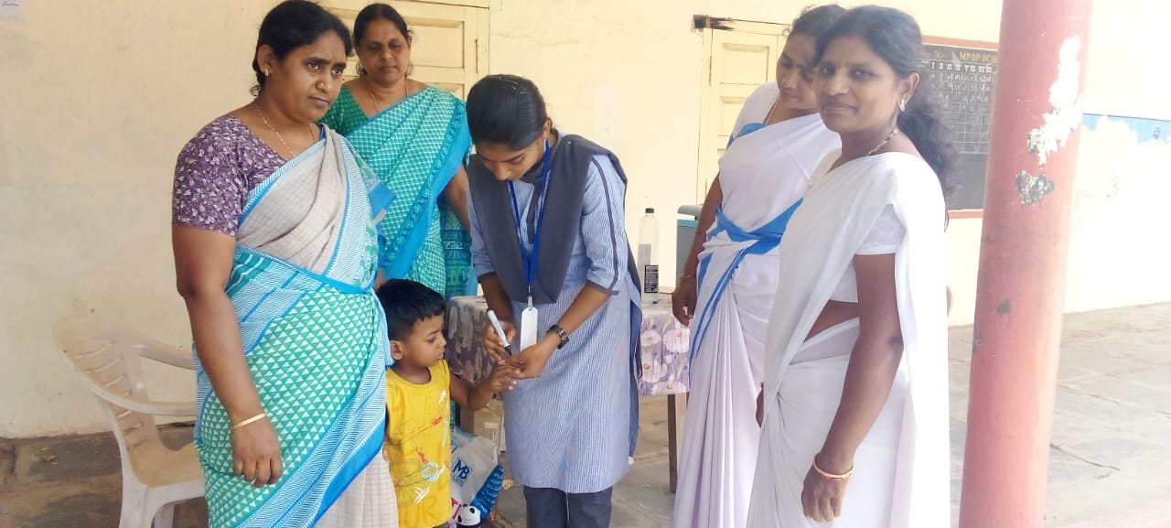
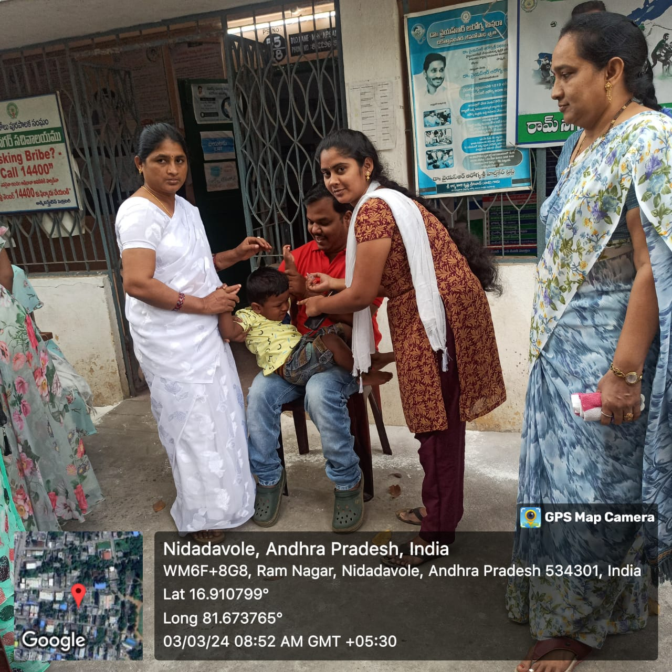
Pulse Polio Campaign
